**BuyMobilePhoneTest:**

**package** in.amazon.testscripts;

**import** java.util.ArrayList;

**import** org.openqa.selenium.WebDriver;

**import** org.openqa.selenium.chrome.ChromeDriver;

**import** org.testng.annotations.BeforeTest;

**import** org.testng.annotations.Test;

**import** org.testng.Assert;

**import** org.testng.annotations.AfterTest;

**import** in.amazon.pages.AllMobileBrands;

**import** in.amazon.pages.ApplePhones;

**import** in.amazon.pages.BuyPhone;

**import** in.amazon.pages.LandingPage;

**import** in.amazon.pages.SignIn;

**public** **class** BuyMobilePhoneTest {

WebDriver driver;

@BeforeTest

**public** **void** launchApplication() {

//1. Open the browser

driver = **new** ChromeDriver();

//2. Maximize it

driver.manage().window().maximize();

//3. Navigate to https://www.amazon.in/

driver.get("https://amazon.in");

}

@Test

**public** **void** buyMobile() {

// 4. Click on 'Mobiles' in the navigation bar

LandingPage landingpage = **new** LandingPage(driver); //Class object = new Class() ;

landingpage.clickMobiles(); //object.method()

// 5. Hover the pointer over 'Mobiles & Accessories'

AllMobileBrands allMobilesBrands = **new** AllMobileBrands(driver);

allMobilesBrands.hoverOverMobilesAndAccessories();

// 6. Click on 'Apple' in the sub-menu

allMobilesBrands.clickApple();

// 7. Click on first available phone

ApplePhones applePhones = **new** ApplePhones(driver);

applePhones.clickFirstMobile();

// 8. Switch focus on new tab

ArrayList<String> tabs = **new** ArrayList<>(driver.getWindowHandles());

driver.switchTo().window(tabs.get(1));

// 9. Click on 'Buy Now' button

BuyPhone buyPhone = **new** BuyPhone(driver);

buyPhone.clickBuyNowBtn();

// 10.Verify user sees the text 'Sign in' on the last page

SignIn signIn = **new** SignIn(driver);

String expectedText = "Sign in";

String actualText = signIn.getSignInText();

Assert.*assertEquals*(actualText, expectedText);

}

// 11. Close the browser

@AfterTest

**public** **void** closeBrowser() {

driver.quit();

}

}

**AllMobileBrands:**

**package** in.amazon.pages;

**import** java.time.Duration;

**import** org.openqa.selenium.WebDriver;

**import** org.openqa.selenium.WebElement;

**import** org.openqa.selenium.interactions.Actions;

**import** org.openqa.selenium.support.FindBy;

**import** org.openqa.selenium.support.PageFactory;

**import** org.openqa.selenium.support.ui.ExpectedConditions;

**import** org.openqa.selenium.support.ui.WebDriverWait;

**public** **class** AllMobileBrands {

**private** Actions actions;

**private** WebDriverWait wait;

@FindBy(linkText = "Mobiles & Accessories")

**private** WebElement mobilesAndAccessories;

**public** AllMobileBrands(WebDriver driver) {

PageFactory.*initElements*(driver, **this**);

actions = **new** Actions(driver);

wait = **new** WebDriverWait(driver, Duration.*ofSeconds*(60));

}

**public** **void** hoverOverMobilesAndAccessories() {

actions.moveToElement(mobilesAndAccessories).build().perform();

}

**public** **void** clickApple() {

WebElement apple = **null**;

wait.until(ExpectedConditions.*invisibilityOf*(apple));

apple.click();

}

}

**Output:**

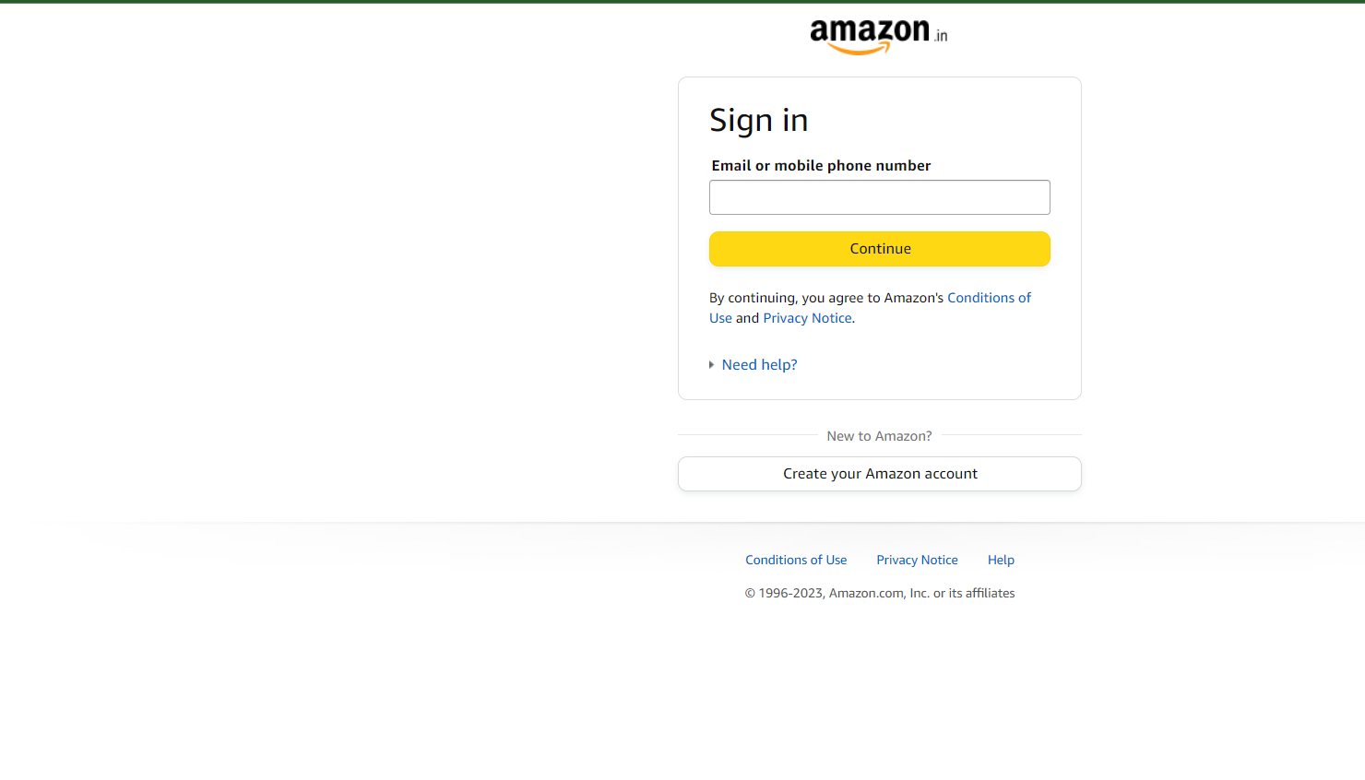

**VerifyErrorMessageTest:**

**package** in.amazon.testscripts;

**import** org.openqa.selenium.WebDriver;

**import** org.openqa.selenium.chrome.ChromeDriver;

**import** org.testng.Assert;

**import** org.testng.annotations.BeforeTest;

**import** org.testng.annotations.Test;

**import** in.amazon.pages.LandingPage;

**import** in.amazon.pages.SignIn;

**public** **class** VerifyErrorMessageTest **extends** BaseTest {

WebDriver driver;

@BeforeTest

**public** **void** launchApplication() {

//1. Open the browser

driver = **new** ChromeDriver();

//2. Maximize it

driver.manage().window().maximize();

//3. Navigate to https://www.amazon.in/

driver.get("https://amazon.in");

}

@Test

**public** **void** VerifyErrorMsg() {

// 4. Hover the pointer over Hello Sign-in menu

LandingPage landingpage = **new** LandingPage(driver);

landingPagehoverOverHelloSignInMenu();

// 5. Click on 'Sign-in' button in the sub-menu

landingpage.clickSignInBtn();

// 6. Enter invalid username in the email textbox

SignIn signIn = **new** SignIn(driver);

signIn.enterEmail("batman554466@gmail.com");

// 7. Click on 'Continue' button

signIn.clickContinueBtn();

// 8. Verify the error message - 'We cannot find an account with that email

// address' is displayed to the user

String expectedErrMsg = "We cannot find an account with that email";

String actualErrMsg = signIn.getErrMsg();

Assert.*assertEquals*(actualErrMsg, expectedErrMsg);

}

**private** **void** landingPagehoverOverHelloSignInMenu() {

// **TODO** Auto-generated method stub

}

}

**BaseTest:**

**package** in.amazon.testscripts;

**import** org.openqa.selenium.WebDriver;

**import** org.openqa.selenium.chrome.ChromeDriver;

**import** org.testng.annotations.AfterTest;

**import** org.testng.annotations.BeforeTest;

**public** **class** BaseTest {

WebDriver driver;

@BeforeTest

**public** **void** launchApplication() {

// 1. Open the browser

driver = **new** ChromeDriver();

// 2. Maximize it

driver.manage().window().maximize();

// 3. Navigate to https://www.amazon.in/

driver.get("https://amazon.in");

}

// 9. Close the browser

@AfterTest

**public** **void** closeBrowser() {

driver.quit();

}

}

**Output:**

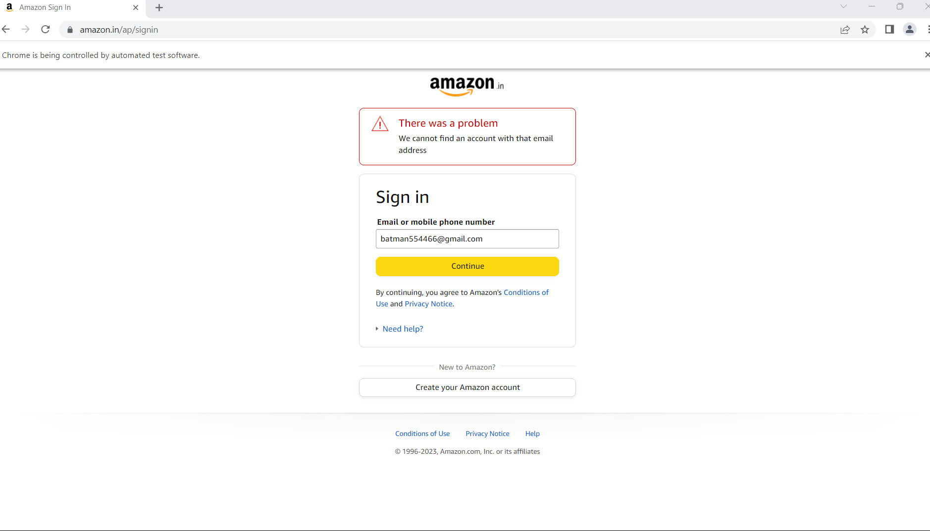

**DDF:**

**package** in.amazon.testscripts;

**import** java.io.IOException;

**import** org.testng.Assert;

**import** org.testng.annotations.Test;

**import** in.amazon.pages.LandingPage;

**import** in.amazon.pages.SignIn;

**import** utils.ReadExcel;

**public** **class** DDF **extends** BaseTest {

// Data Driven Framework - when the same application is tested aganist different

// set of data.

@Test

**public** **void** VerifyErrorMsg() **throws** IOException {

// 4. Hover the pointer over Hello Sign-in menu

LandingPage landingpage = **new** LandingPage(driver);

landingPagehoverOverHelloSignInMenu();

// 5. Click on 'Sign-in' button in the sub-menu

landingpage.clickSignInBtn();

String[][] data = ReadExcel.*getData*("resource//TestData.xlsx", "Sheet1");

**for** (**int** i = 1; i < 6; i++) {

String username = data[i][1];

// 6. Enter invalid username in the email textbox

SignIn signIn = **new** SignIn(driver);

signIn.enterEmail(username);

// 7. Click on 'Continue' button

signIn.clickContinueBtn();

// 8. Verify the error message - 'We cannot find an account with that email

// address' is displayed to the user

String expectedErrMsg = "We cannot find an account with that email";

String actualErrMsg = signIn.getErrMsg();

Assert.*assertEquals*(actualErrMsg, expectedErrMsg);

}

}

**private** **void** landingPagehoverOverHelloSignInMenu() {

// **TODO** Auto-generated method stub

}

**Test Result Report:**

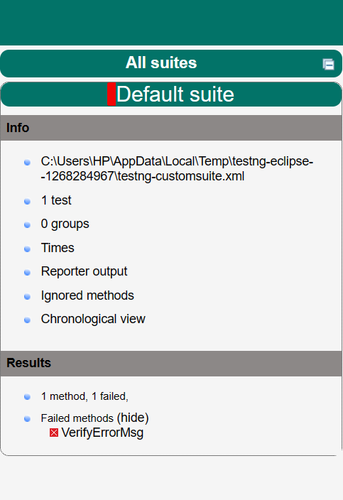

**ApplePhones.java:**

**package** in.amazon.pages;

**import** org.openqa.selenium.WebDriver;

**import** org.openqa.selenium.WebElement;

**import** org.openqa.selenium.support.FindBy;

**import** org.openqa.selenium.support.PageFactory;

**public** **class** ApplePhones {

@FindBy(xpath = "(//div[contains(@class,'card-container')])[1]")

**private** WebElement firstMobile;

**public** ApplePhones(WebDriver driver) {

PageFactory.*initElements*(driver, **this**);

}

**public** **void** clickFirstMobile() {

firstMobile.click();

}

}

**BuyPhone.java:**

**package** in.amazon.pages;

**import** org.openqa.selenium.WebDriver;

**import** org.openqa.selenium.WebElement;

**import** org.openqa.selenium.support.FindBy;

**import** org.openqa.selenium.support.PageFactory;

**public** **class** BuyPhone {

@FindBy(id = "buy-now-button")

**private** WebElement buyNowBtn;

**public** BuyPhone(WebDriver driver) {

PageFactory.*initElements*(driver, **this**);

}

**public** **void** clickBuyNowBtn() {

buyNowBtn.click();

}

}

**LandingPage.java:**

**package** in.amazon.pages;

**import** org.openqa.selenium.WebDriver;

**import** org.openqa.selenium.WebElement;

**import** org.openqa.selenium.interactions.Actions;

**import** org.openqa.selenium.support.FindBy;

**import** org.openqa.selenium.support.PageFactory;

**public** **class** LandingPage {

//Locator of the web-elements on Landing page of amazon

//private WebElement mobiles = driver.findElement(By.linkText("Mobiles"));

//mobiles.click();

**private** Actions actions;

@FindBy(linkText = "Mobiles")

**private** WebElement mobiles;

@FindBy(id = "nav-link-accountList")

**private** WebElement signInMenu;

@FindBy(linkText = "Sign in")

**private** WebElement signInBtn;

**public** LandingPage(WebDriver driver) {

PageFactory.*initElements*(driver, **this**);

actions = **new** Actions(driver);

}

**public** **void** clickMobiles() {

mobiles.click();

}

**public** **void** hoverOverHelloSignInMenu() {

actions.moveToElement(signInMenu).build().perform();

}

**public** **void** clickSignInBtn() {

signInBtn.click();

}

}

**SignIn.java:**

**package** in.amazon.pages;

**import** org.openqa.selenium.WebDriver;

**import** org.openqa.selenium.WebElement;

**import** org.openqa.selenium.support.FindBy;

**import** org.openqa.selenium.support.PageFactory;

**public** **class** SignIn {

@FindBy(xpath = "//h1[contains(@class,'small')]")

**private** WebElement signInText;

@FindBy(id = "ap_email")

**private** WebElement emailTextBox;

@FindBy(id = "continue")

**private** WebElement continueBtn;

@FindBy(xpath = "//span[contains(@class,'a-list-item')]")

**private** WebElement errMsg;

**public** SignIn(WebDriver driver) {

PageFactory.*initElements*(driver, **this**);

}

**public** String getSignInText() {

String text = signInText.getText();

**return** text;

}

**public** **void** enterEmail(String email) {

emailTextBox.sendKeys(email);

}

**public** **void** clickContinueBtn() {

continueBtn.click();

}

**public** String getErrMsg() {

String message = errMsg.getText();

**return** message;

}

**ReadExcel.java:**

**package** utils;

**import** java.io.File;

**import** java.io.FileInputStream;

**import** java.io.IOException;

**import** org.apache.poi.ss.usermodel.Cell;

**import** org.apache.poi.ss.usermodel.DataFormatter;

**import** org.apache.poi.ss.usermodel.Row;

**import** org.apache.poi.ss.usermodel.Sheet;

**import** org.apache.poi.ss.usermodel.Workbook;

**import** org.apache.poi.xssf.usermodel.XSSFWorkbook;

**public** **class** ReadExcel {

**public** **static** String[][] getData(String fileName, String sheetName) **throws** IOException {

File file = **new** File(fileName);

FileInputStream ips = **new** FileInputStream(file); // FileOutputStream for writing the data on excel sheet

Workbook Wb = **new** XSSFWorkbook(ips);

Sheet Sh = Wb.getSheet(sheetName);

**int** rowNum = Sh.getLastRowNum() + 1;

**int** colNum = Sh.getRow(0).getLastCellNum();

String[][] data = **new** String[rowNum][colNum];

**for** (**int** i = 0; i < rowNum; i++) {

Row row = Sh.getRow(i);

**for** (**int** j = 0; j < colNum; j++) {

Cell cell = row.getCell(j);

String value = **new** DataFormatter().formatCellValue(cell);

data[i][j] = value;

}

}

**return** data;

}

}

}

**Jenkins:**

**JenkinsDemo.java:**

**package** in.amazon.JenkinDemo;

**import** org.openqa.selenium.WebDriver;

**import** org.openqa.selenium.chrome.ChromeDriver;

**import** org.testng.annotations.BeforeTest;

**import** org.testng.annotations.Test;

**import** org.testng.Assert;

**import** org.testng.annotations.AfterTest;

**public** **class** VerifyTitle {

WebDriver driver;

@BeforeTest

**public** **void** launchApplication() {

driver = **new** ChromeDriver();

driver.get("https://facebook.com");

}

@Test

**public** **void** titleVerification() {

String expectedTitle = "Facebook - log in or sign up";

String actualTitle = driver.getTitle();

Assert.*assertEquals*(actualTitle, expectedTitle);

}

@AfterTest

**public** **void** closeBrowser() {

driver.quit();

}

}

**Output:**

